**CSS3 Notes**

Cascading Style Sheets describe how HTML elements are to be displayed on screen. We will store our style definitions in external files with the **.css** extension in a folder named **css** and link to it in the <head> section of the html document.

<head>

<link rel=“stylesheet” href=“**css/index.css**” />

</head>

CSS3 is the latest version of CSS with additional features to allow setting the background, borders, image values, text effects and animations.

1. Activity: See how one HTML page is displayed with four different stylesheets.

Visit: <http://www.w3schools.com/css/css_intro.asp>

Click on the "Stylesheet 1", "Stylesheet 2", "Stylesheet 3", "Stylesheet 4" links to see the different styles:

1. A CSS rule-set consists of a **selector** and a declaration block containing property/value declarations each ending with a semicolon. Comment in CSS are within /* */

body {

**color**: red; /*red, rgb(88,0,0), #ff0000*/

**background-color**:#808080;

**font-style**: italic;

**font-weight**: bold;

**font-family**: Arial, “Times New Roman”, Helvetica, san-serif;

**font-size**: 16px; /*1em*/

}

You can select elements by

* + tag name: (eg. body, h1, p, a)
  + class name: (e.g., .color, .strong, .loud, .subtle, .error)
  + id: (e.g., #counter, #btnLogin, #imglogo).

You can be more specific by chaining selectors together

* + h1 a
  + ul .loud

In the **hmtl** file, use classes when you have more than one items on the page with the same value:

html: <h1 class=“loud”> Hi </h1>

css: .loud {

font-style: italic;

}

Use ids when id values need to be unique on a page

html: <p id=“closing”> bye </p>

css: #closing{

background-color: yellow;

}

1. Download the startup file **CSSBasics.zip** from D2L and extract the **CSSBasics** folder.

3a. Open **index.html** in a browser to see the original formatting.

tag: body, h1, h2, img, div, p, ul, li, a

class: category, highlight

id: section_about, section_content, section_resources, bumble, carpenter, honey, killer

3b. Visit: <http://www.w3schools.com/css/default.asp> to learn about the different styles available and apply the following styles:

* 1. highlight class : font-style should be italics
  2. header style h2: transform text to all caps
  3. category class : create a 1px solid blue border around each category calls
  4. hypertext links : The hypertext links should not be underlined. Instead make them bold, red
  5. unsorted list (ul): should have a colorful background. (Choose any color)
  6. Chang font of document to be Arial
  7. Center the image on the page
  8. section_about: Change the **line-height** to 0.8 to reduce the spacing between lines
  9. paragraphs in the category classes: **font-size** should be 14 px but set this using em value.

**CSS colors**: Colors in CSS are most often specified by: a valid color name - like "red", an RGB value - like "rgb(255, 0, 0)"a HEX value - like "#ff0000. There are a number of tools available to determine proper color: <http://color.adobe.com>

**CSS borders**: specify style width and color

border: 5px solid red;

**CSS Text:**

text-align: left; */*right, center , justify*/*

text-decoration: none; */* removes underline from links – underline, overline, line-through*/*

text-transformation: uppercase; */* lowercase, capitalize */*

**CSS Font:** Commonly used font formations <http://www.w3schools.com/cssref/css_websafe_fonts.asp>

The font-family property should hold several font names as a "fallback" system. If the browser does not support the first font, it tries the next font, and so on.

font-family: "Times New Roman", Times, serif;

**CSS Unit size: px, em, %**

Many CSS properties take "length" values, such as width, margin, padding, font-size, border-width, etc. Length is a number followed by a length unit, such as 10px, 2em, etc. Pixel is a static measurement, while percent and EM are relative measurements. The size of an EM or percent depends on its *parent*. If the text size of body is 16 pixels, then 150% or 1.5 EM will be 24 pixels (1.5 * 16).

Setting the text size with pixels gives you full control over the text size: font-size: 40px;

The **em** size unit is recommended by the W3C. Circumstances that will break layouts based on absolute values can be managed by layouts based on **em** values. 1em is equal to the current font size. The default text size in browsers is 16px. So, the default size of 1em is 16px. The size can be calculated from pixels to em using this formula: pixels/16=em (Article: <https://css-tricks.com/why-ems/> )

font-size: 2.5em; /* 40px/16=2.5em */

PX to Em Converter: <http://www.w3schools.com/cssref/css_pxtoemconversion.asp>

.

1. Basic Page Layout

<h1>Hello</h1>

Elements in CSS are laid out according to the box model consisting of an element’s content, padding, border and margin:

* The content is the actual HTML content the element contains. The width and height refers to the content

• The padding is the space between the content and the border

• The border defines the edge of an element

• The margin is the space between the border and the edge of its parent element

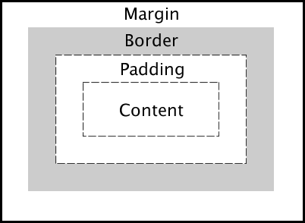

4a. In Brackets, open the html document named **page.html** and its related **page.css.**  Notice that the <footer> and section #test2 will not be displayed.

4b. In the <head> section add a link (*above* the link to the **page.css)** to the Yahoo CSS style reset sheet found on <http://yuilibrary.com/yui/docs/cssreset/>

<link rel="stylesheet" type="text/css" href="http://yui.yahooapis.com/3.18.1/build/cssreset/cssreset-min.css">

This style sheet will set all of the styles of every HTML element to a basic, identical style that you can build from. This reset stylesheet will made the headings identical to the rest of the body text.

4c. Chrome’s developer view, view the page as **Google’s Nexus 7 emulator** and show ruler

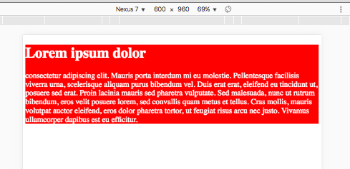

4d. Modify page.css to show **#test2** section and style it to make the background blue.

**footer**{

display:none;

}

#**test1**{

background-color: red;

color:white;

}

**#test2**{

background-color: blue;

color:white;

}

4e. Change the size of the content in the box using the **width** attribute. Content can be set to either a precise pixel value or a relative value based on the size of the parent.

#test1{

background-color: red;

color:white;

**width: 50%;**

}

#test2{

background-color: blue;

color:white;

**width: 483px;**

}

Change the size of the emulated screen and note how the elements react.

4d. Change the padding (the distance between the content and edges of the container element)

The **width** attribute sets the width of the content, not the width of the entire element.

Change the widths of both #test1 and #test2 to **600px**. Then add a **padding** value of **25px** to #test1.

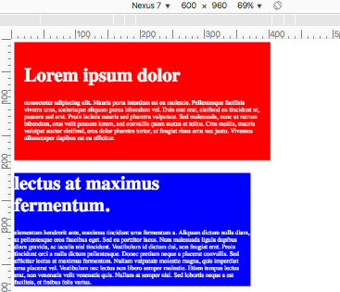#test1{

background-color: red;

color:white;

**width: 600px;**

**padding: 25px;**

}

#test2{

background-color: blue;

color:white;

**width: 600px;**

}

The padding adds space between the content and the edge of the element.

4e. Change the margin (the distance between the border and the edge of the parent

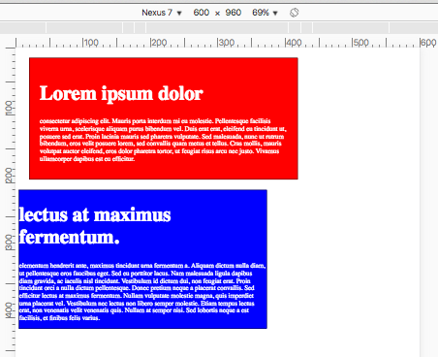#test1{

background-color: red;

color:white;

width: 600px;

padding: 25px;

**border: 1px solid black;**

**margin: 25px;**

}

#test2{

background-color: blue;

color:white;

width: 600px;

**border: 1px solid black**;

}

4f. floating elements

When placing elements on a page, the browser will always attempt to lay elements out vertically. You can override the default layout with the float attribute.

Float places an element on either the right or left side of its parent element and has the remaining elements flow around it. Any elements in the document before the floated element will not be affected.

Multiple floated elements in a row will display next to each other if there is room.

Multi-column layout is most effective on large screen devices such as tablets.

Change style sheet to make the two sections appear next to each other:

#container {

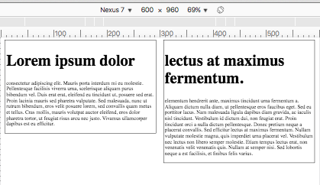 **margin: 5px;**

}

#test1{

**float: left;**

**width: 48%;**

padding: 3px;

border: 1px solid black;

}

#test2{

**float: right;**

**width: 48%;**

padding: 3px;

border: 1px solid black;

}

4g. Use the **clear** attribute

Elements after a floating element will flow around it. To avoid this, use the **clear** property. The **clear** property specifies on which sides of an element floating elements are not allowed to float (left, right, both)

Make the <footer> and style its font-size, background-color and text color

footer{

font-size: 0.75em;

background-color: black;

color:white;

**clear:both;**

}

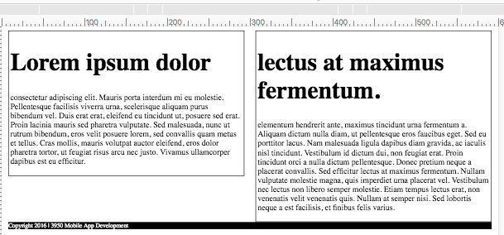

Activities:

Activity 1: Experiment with background properties: <http://www.w3schools.com/css/css_background.asp>

background- color: lightblue;

background-image: url( “../img/paper.gif”) ;

background-repeat: no-repeat; /* by default the background image will repeat*/

The background-image property specifies an image to use as the background of an element. By default, the image is repeated so it covers the entire element. Showing the background image only once is also specified by the background-repeat property

Activity 2: Experiment with navigation bars.

Having easy-to-use navigation is important for any web site. With CSS you can transform boring HTML menus into good-looking navigation bars.

<http://www.w3schools.com/css/css_navbar.asp>

Convert an unsorted list to a navigation bar

<ul>  
  <li><a href="default.asp">Home</a></li>  
  <li><a href="news.asp">News</a></li>  
  <li><a href="contact.asp">Contact</a></li>  
  <li><a href="about.asp">About</a></li>  
</ul>

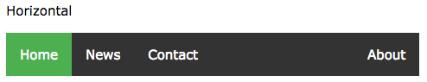

**CSSBasic index.html**

<body>

<div id="section_about">

<h1>Bees</h1>

<img src="img/bees.jpeg" alt="bees" />

<p>There are about 20,000 different species of bees in the world. Bees live in colonies that contain the queen bee, the worker bee and the drone. The worker bee and the queen bee are both female, but only the queen bee can reproduce. All drones are male. Worker bees clean the hive, collecting pollen and nectar to feed the colony and they take care of the offspring. The drone&#39;s only job is to mate with the queen. The queen&#39;s only job is to lay eggs.</p>

</div><!-- about -->

​

<div id="section_content" >

    <div id="bumble" class="category">

<h2>Bumble Bees</h2>

<p>Bumblebees are considered to be beneficial insects because they pollinate crops and plants. They are very social bees and live in large <span class="highlight">families</span>. </p>

<p>Unlike honeybees, bumblebees can sting more than once because their stingers are smooth and do not get caught in the skin when they fly away.</p>

</div><!-- bumble -->

​

<div id="carpenter" class="category">

<h2>Carpenter Bees </h2>

<p>Carpenter bees are solitary bees. They build nests just for themselves and only feed their own young. They get their name from their ability to drill through wood. Carpenter bee stingers are not barbed, so they are able to sting over and over again.</p>

</div><!--capenter -->

​

<div id="honey" class="category">

<h2>Honeybees</h2>

<p>Honeybees live in large <span class="highlight">families</span> and are found all over the world. The honeybee is the only social insect whose colony can survive many years. That is because they huddle together and eat honey to keep themselves alive during the winter months. </p>

<p>Honeybees pollinate more than 100 crops in the U.S. </p>

<p>Their wings flap 11,000 times per minute, which is why it sounds like they are <span class="highlight">buzzing</span>. Honeybees can only sting once, because their stingers are barbed and tear off when they try to get away.</p>

</div><!-- honey -->

​

<div id="killer" class="category">

<h2>Killer Bees</h2>

<p>Africanized <span class="highlight">killer</span> bees look a lot like regular honeybees, but they have different wing measurements. Africanized bees lives in South America and the Western and Southern United States. They have been known to chase people for over a quarter of a mile once they get excited and aggressive. </p>

<p>Even though they are called <span class="highlight">killer</span> bees, their venom is no more dangerous than regular honeybees. However, these bees tend to attack in larger numbers, which poses a greater danger to humans, especially those who are allergic to bee stings.</p>

<p>Africanized bees can only sting once because their stingers are barbed and tear off when they try to get away.</p>

</div> <!--killer -->

</div> <!--category -->

​

<div id="section_resources">

<h1 id="links">Links</h1>

<ul>

<li>To find out more click: <a href="http://pestworldforkids.org/pest-guide/bees/"> http://pestworldforkids.org/pest-guide/bees/ </a></li>

<li><a href="#section_about">Go to top of page </a></li>

</ul>

</div> <!-- resources -->

</body>